Group 07 RationalGRL

Page 2................ GRL Model constructed from discussion

Page 3................ Statistics of the annotation

Page 4................ Interesting arguments found

This transcript only contained three types of argument we did not encounter explicitely, namely

1. arguing about the relevance of an actor, and
2. arguing about the type of decomposition relation (OR or AND).
3. introducing a dependency relation.

**Note:** Dependency statements are not of the type "Actor" depends on "Actor", but rather about the dependency of specific functionality that belongs to actors. So we have to change these argument schemes and critical questions.

TODO;

* Collect statistics of three transcripts
* List all the moves and their effects, cluster those that have the same effect
* Win!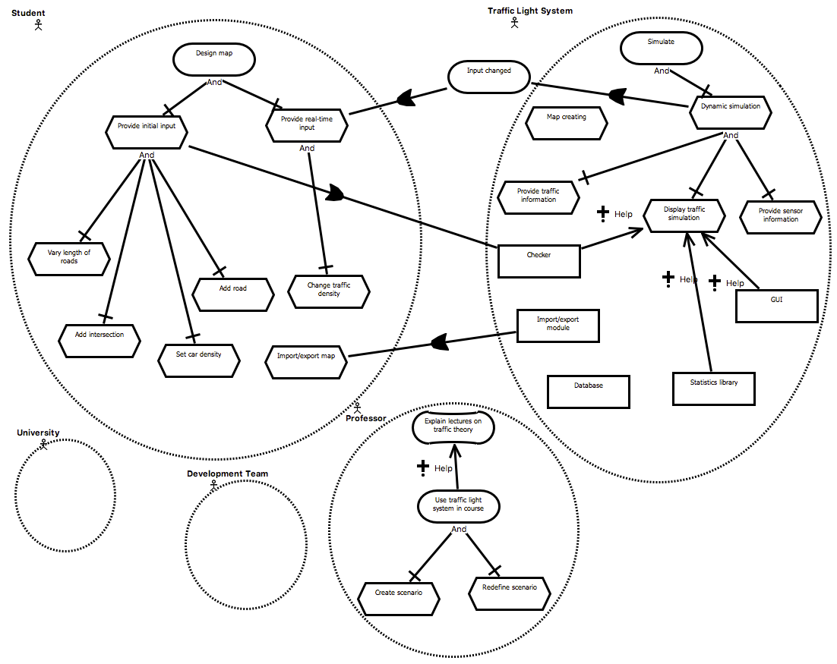 **Statistics**

|  |  |  |  |  |  |  |  |  |  |  |  |  |  |  |  |  |  |  |  |  |  |  |  |  |  |  |  |  |  |  |  |  |  |  |  |  |  |  |  |  |  |  |  |  |  |  |  |  |  |  |  |  |  |  |  |  |  |  |  |  |  |  |  |  |  |  |  |  |  |  |  |  |  |  |
| --- | --- | --- | --- | --- | --- | --- | --- | --- | --- | --- | --- | --- | --- | --- | --- | --- | --- | --- | --- | --- | --- | --- | --- | --- | --- | --- | --- | --- | --- | --- | --- | --- | --- | --- | --- | --- | --- | --- | --- | --- | --- | --- | --- | --- | --- | --- | --- | --- | --- | --- | --- | --- | --- | --- | --- | --- | --- | --- | --- | --- | --- | --- | --- | --- | --- | --- | --- | --- | --- | --- | --- | --- | --- | --- |
| |  |  |  | | --- | --- | --- | | **Argument Schemes** | **Found** | **Added** | | AS0: Actor | 5 |  | | AS1: Resource | 5 |  | | AS2: Task/action | 17 |  | | AS3: Goal | 2 |  | | AS4: Softgoal | 2 |  | | AS5: Task realizes goal | 4 |  | | AS6: Task contributes to softgoal |  |  | | AS7: Goal contributes to softgoal | 1 |  | | AS8: Resource contributes to task | 3 |  | | AS9: Actor depends on actor | 3 |  | | |  |  | | --- | --- | | **Critical questions** | **Found** | | CQ1: Is the resource available? |  | | CQ2: Is the task possible? | 1 | | CQ3: Can the desired goal be realized? |  | | CQ4: Is the softgoal legitimate? |  | | CQ5a: Will the task realize the goal? |  | | CQ5b: Are there alternative ways to realize the same goal? |  | | CQ6a: Are there alternative ways to contribute to the same softgoal? |  | | CQ6b: Does the task have negative side effects / same softgoal? |  | | CQ6c: Does the task have negative side effects / other softgoal? |  | | CQ6d: Does the task contribute to some other softgoal? |  | | CQ6e: Does the task preclude other task contributing to other softgoal? |  | | CQ7a: Does the goal contribute to the softgoal? |  | | CQ7b: Does the goal contribute to some other softgoal? |  | | CQ8a: Is the resource required in order to perform the task? |  | | CQ8b: Can other resources be used for the task? |  | | CQ8c: Is the resource required in order to perform the task? |  | | CQ8d: Does using the resource make other resources unavailable? |  | | CQ9: Does the actor depend on any actors? |  | | | |
| **Other annotations** | | **Found** |
| CQ: Is the actor relevant? | | 2 |
| AS: Task x-decomposes into task (x in {XOR,AND,OR}) | | 11 |
| AS: Task contributes negatively to softgoal | |  |
| CQ: Is the task is useful/relevant? If no: remove task | |  |
| CQ: Is the description of an IE clear? (clarification). If no: replace description | | 1 |
| CQ: Is the description of the IE specific enough / too specific? If no: replace description | | 2 |
| CQ: Does the task decompose into the other task? | |  |
| CQ: What kind of decomposition (AND/OR/XOR)? | | 1 |
| Counterargument | | 2 |
| CQ: does the task contribute to the goal? | |  |

**Arguing about the relevance of an actor**

|  |  |  |
| --- | --- | --- |
| 0:10:55.2  PERSON 1 | Maybe developers or | **[4 actor (AS0)]** Development team is an actor |
| 0:11:00.8  PERSON 2 | Development team, I don’t know. Because that’s- in this context it looks like she’s gonna make the software | **[5 critical question CQ0 for 4]** Is actor "development team" relevant?  **[6 answer to 5]** No, it looks like the professor will develop the softgoal.  **[6a remove]** Actor "Development team" is removed |
| 0:12:17.4  PERSON 1 | The environment is university | **[8 critical question (CQ0) for 3]** Is the actor "University" relevant?  **[9 answer to 8]** No, the environment is university, so it is not an actor. |
| 0:18:13.4  PERSON 2 | I think we can still do developers here. To the system | **[16 counter argument for 6a]** According to the specification the professor doesn't actually develop the software. |
| 0:18:18.2  PERSON 1 | Yeah? |
| 0:18:19.8  PERSON 2 | Yeah, it isn’t mentioned but, the professor does- |
| 0:18:22.9  PERSON 1 | Yeah, when the system gets stuck they also have to be [inaudible] ok. So development team |
| 0:18:31.6  PERSON 2 | Yeah and are there also administrators or something. System administrator, I don’t know. But it isn’t mentioned here and I don’t know how closely you have to follow this so |

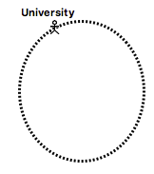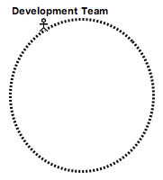

The professor doesn't actually develop the software, so Development team is relevant.

AS0: "Development team" is an Actor

"Development team" is not an Actor

*Irrelevant actor (CQ?)*

AS0: "University" is an Actor

*Irrelevant actor (CQ?)*

"University" is not an actor: it's the environment

**Arguing about a decomposition relation**

|  |  |  |
| --- | --- | --- |
| 0:18:55.7  PERSON 1 | Yeah. And then three processes, static, dynamic and they are related to simulation. | **[17 goal (AS3)]** Actor "System" has goal "Simulate"  **[18 task (AS2)]** Actor "System" has task "Static simulation"  **[19 task (AS2)]** Actor "System has task "Dynamic simulation"  **[20 decomposition (AS?)]** Goal "Simulation" decomposes into "Static simulation" and "Dynamic simulation" |
| 0:30:10.3  PERSON 1 | Yeah. But this is- is this an OR or an AND | **[26 critical question CQ? for 20]** Is the decomposition an AND-decomposition?  **[27 answer to 26]** No, it should be an OR because for the data it is an OR.  **[27a decomposition (AS?)]** Goal "simulate" OR-decomposes into "Static simulation" and "dynamic simulation" |
| 0:30:12.6  PERSON 2 | That’s and OR |
| 0:30:14.3  PERSON 3 | I think it’s an OR |
| 0:30:15.4  PERSON 1 | It’s for the data, it’s an OR |
| 0:30:18.1  PERSON 3 | Yep |
| 0:30:18.4  PERSON 1 | And for the system it’s an AND |
| 0:30:20.8  PERSON 2 | Ok |
| 0:30:22.0  PERSON 1 | I think |
| 0:30:22.5  PERSON 2 | Yeah? |
| 0:30:23.2  PERSON 1 | Yeah, because you have some input, and then that’s- |
| 0:30:29.3  PERSON 2 | Yeah, but didn’t |
| 0:30:29.5  PERSON 1 | Static manner or dynamic. But the system can do both |

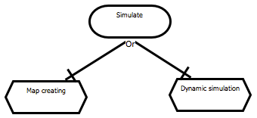

*Incorrect decomposition (CQ?)*

AS?: Goal "simulate" decomposes into tasks "Map creating" and "Dynamic simulation"

AS?: Goal "simulate" OR-decomposes into tasks "Map creating" and "Dynamic simulation"

**Introducing a dependency relation**

|  |  |  |
| --- | --- | --- |
| 0:41:41.9  PERSON 3 | I think it’s a module that’s going to be activated after you’ve designed the map. For example, you design the map and now you’re in the simulation process. It’s before the simulation process. It’s gonna be a module, it’s gonna be run just for checking independencies | **[40 dependency (AS?)]** "Provide initial input" depends on "Checking light behavior" |
| 0:41:57.0  PERSON 2 | Yeah |
| 0:41:57.0  PERSON 1 | Ok |
| 0:41:57.6  PERSON 3 | Ok, we forgot to create these dependencies |
| 0:42:00.3  PERSON 1 | Ok |  |

